SAUL ROAD RESIDENTS ASSOCIATION MEETING

Denvirs Hotel Wednesday 9th at 7pm

www.facebook.com/saulroadresidents
PUBLIC MEETING
IN RESPONSE TO A HUGE DEVELOPMENTS TO THE NORTH AND EAST OF THE SAUL ROAD WE HAVE FORMED A RESIDENTS ASSOCIATION. WE WILL FIGHT FOR THE INTERESTS OF THE AREA AND PREVENT FURTHER CONGESTION OF BOTH SAUL ROAD TOWN CENTRE.
The Down and Ards Area Plan suggests that these lands (see map overleaf) be developed off the as yet un-built ‘Eastern Distributor Road’. Theoretically it is illegal to develop these lands without also contributing to the development of the ‘Eastern Distributor’ Ring-Road.
This ring-road is supposed to connect the first part of the new ring-road at the Ardglass Road Roundabout, down to the Ballyhornan Road, across the Saul Road past Ardfern and down via the Rathkeltair Road to the Belfast Road. It is vital to the economic future of Downpatrick.
Instead of facilitating the ring-road, the developers of this site are; (see map overleaf)
- Building off the Saul Road, overlooking and overshadowing existing house
- Forcing Traffic down the overcrowded Saul Road, Mearne Road and Rathkeltair road.
- Funnelling even more traffic though the over-crowded and congested centre of Downpatrick
- Ignoring the Area Plan and the economic and social development of Downpatrick.
- Choking off future development and employment in the town.

You can help in 2 ways;

- Attend the next meeting at Denvirs Hotel 7pm Wednesday 9th at 7pm
AND / OR
- Write a letter to the planners at Rathkeltair House opposing this development R/2013/0544F.
FOR EXAMPLES OF OBJECTION LETTERS WRITTEN BY OTHERS SEE
www.enright.ie/policies/saulroad or www.facebook.com/saulroadresidents
We need people with skills and knowledge for this campaign – if you can help us please come forward and contact
Declan McGrady declanmcgrady@yahoo.com or
Councillor Cadogan Enright cadogan@enright.ie
or David Archer mefiesto@tiscali.co.uk

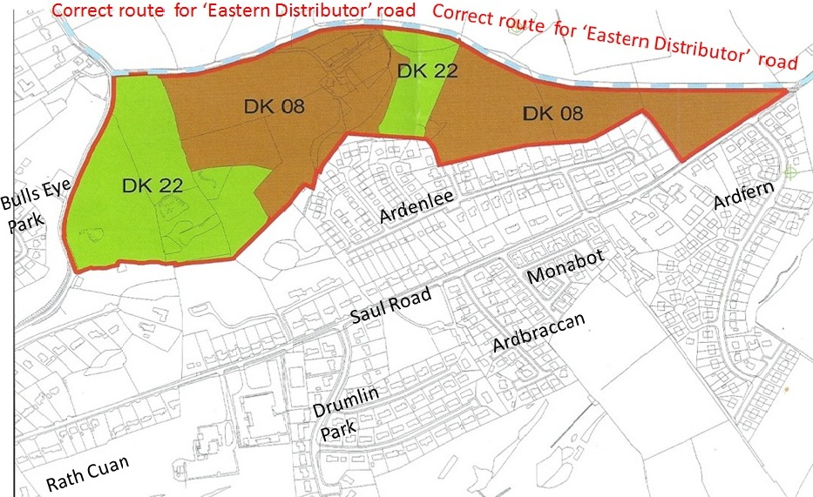

Above map in ‘DK08’ indicates the phases of development to the North of the Saul Road. NOTE that further development around Ardfern but in the ‘Area Plan’ is not shown on above map. This would extend up toward the Ballyhornan Road and Hospital.
Without the new distributor road taking traffic from the hospital across the top of the Saul Road and down to the Belfast Road across the Quoile – then these developments and much more not shown on this map will have to come down the congested Saul Road or Mearne Road into Church Street in the town centre – this would be a disaster for an already congested Downpatrick
FOR EXAMPLES OF OBJECTION LETTERS WRITTEN BY OTHERS SEE
www.enright.ie/policies/saulroad or www.facebook.com/saulroadresidents
We need people with skills and knowledge for this campaign – if you can help us please come forward and contact
Declan McGrady declanmcgrady@yahoo.com or
Councillor Cadogan Enright cadogan@enright.ie
or David Archer mefiesto@tiscali.co.uk

